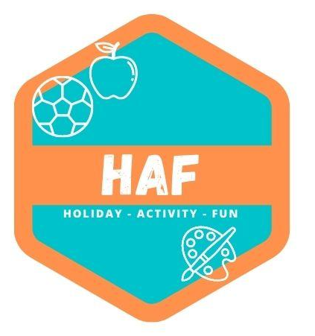

Equalities Policy
At West Lancs HAF we will ensure that we provide a safe and caring environment, free from discrimination, for everyone in our community including children with additional needs.
To achieve the camp’s objective of creating an environment free from discrimination and welcoming to all, the camp will:
• Respect the different racial origins, religions, cultures and languages in a multi-ethnic society
so that each child is valued as an individual without racial or gender stereotyping.
• Not discriminate against children on the grounds of disability, sexual orientation, class, family
status or HIV/Aids status.
• Help all children to celebrate and express their cultural and religious identity by providing a
wide range of appropriate resources and activities.
• Strive to ensure that children feel good about themselves and others, by celebrating the
differences which make us all unique individuals.
• Ensure that its services are available to all parents/carers and children in the local community.
• Ensure that the camp’s recruitment policies and procedures are open, fair and non
discriminatory.
• Work to fulfil all the legal requirements of the Equality Act 2010.
• We will monitor and review the effectiveness of our inclusive practice by conducting an
Inclusion Audit on an annual basis.

Challenging inappropriate attitudes and practices
We will challenge inappropriate attitudes and practices by engaging children and adults in discussion, by displaying positive images of race and disability, and through our staff modelling anti-discriminatory behaviour at all times.
Racial harassment
The camp will not tolerate any form of racial harassment. The camp will challenge racist and discriminatory remarks, attitudes and behaviour from the children at the camp, from staff and from any other adults on camp premises (e.g. parents/carers collecting children).

Promoting equal opportunities
West Lancs HAF Equal Opportunities Named Coordinator (ENCO) is Matt Tuffs.

The ENCO is responsible for ensuring that:
• Staff receive relevant and appropriate training
• The Equalities Policy is consistent with current legislation and guidance
• Appropriate action is taken wherever discriminatory behaviour, language or attitudes occur.

Children with additional needs
Our camp recognises that some children have additional needs or physical disabilities that require particular support and assistance. We will assess the individual needs of each child in consultation with their parents prior to their attending the camp, and will make reasonable adjustments to ensure that children can access our services and are made to feel welcome.

This policy was adopted by: West Lancs HAF | Date: 20/03/2023
Reviewed on: 21/06/25  To be reviewed: 21/06/26 | 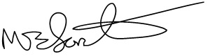  Signed: M.Forster

